Abstract

Climate Change can be defined as the shift of global climate and weather patterns.

1. Introduction

2. Climate change

2.1. Definition

Providing the definition of climate change, including information about what it is, how it happens, what its impacts are, …

2.2. Current situation

Giving several current statistics about climate change. It is required that these statistics come from trusted sources.

2.3. Mitigations by authorities

Listing some actions taken by countries and organizations.

2.4. Dataset

Showing the main dataset used in this project.

3. Methodology

**3.1. Exploratory analysis**

Providing graphs and insights of features in dataset.

**3.1.1. Annual Surface Temperature Change**

Standard temperature is the average surface temperature from 1951-1980.

Countries: Countries tend to have increasing deviations in surface temperature compared to the standard temperature over the years, and most are experiencing temperature rises.

World: Despite fluctuations, the world's temperature overall continues to rise rapidly compared to the standard (in 1961, it only increased by 0.211°C compared to the standard temperature, but in 2020, it increased by 1.711°C). The world surface temperature change decreased by 0.314°C in 1976 (the lowest decrease) and increased by 1.711°C in 2022 (the highest increase).

The combination of technological advancements, supportive policies, economic benefits, and environmental considerations has created a favorable environment for the accelerated growth of renewable energy. Consequently, the relative increase in electricity production from non-renewable sources is slower as the global energy transition gains momentum towards a more sustainable future.

Vietnam: Vietnam's deviation in temperature from the standard fluctuates significantly, but there is a trend of increasing temperature compared to the standard over the years. Specifically, in 1986-1987 (in 1986, it only increased by 0.088, but in 1987, it increased by 1.048 compared to the standard) and 1997-1998 (in 1997, it only increased by 0.310, but in 1998, it increased by 1.307 compared to the standard), Vietnam experienced significant temperature changes.

During the period 1961-1980, surface temperatures fluctuated around the standard (as the standard is the average surface temperature from 1951-1980).

It can be observed that most countries near the North Pole have significantly increased surface temperatures compared to the standard, and the temperature rise is greater than in other regions. One of the reasons is that ice and snow are white and therefore reflect a lot of sunlight. After the initial warming and melting of the snow and ice, the white surface is replaced by a darker surface of the open ocean, which absorbs more sunlight, thus leading to further local warming. Climate change affects the melting of ice at both poles, alters ocean currents, and increases greenhouse gas emissions.

**3.1.1. Renewable Energy**

World:

* Electricity Generation:

The amount of electricity generated from both renewable and non-renewable energy sources is increasing, however, the amount of electricity produced from non-renewable energy sources is increasing at a slower pace compared to renewable energy. The proportion of electricity generated from non-renewable energy sources is quite high but is showing a decreasing trend.

The electricity output generated from fossil fuels accounts for the highest proportion.

In electricity production from renewable energy sources, hydropower contributes the highest proportion to the total electricity output generated from renewable energy. Electricity generated from wind energy also experiences rapid growth.

In electricity production from non-renewable energy sources, electricity generated from fossil fuels accounts for the highest proportion, followed by nuclear energy.

* Electricity Installed Capacity:

Quite similar to Electricity Generation.

The electricity installed capacity of both renewable and non-renewable energy is increasing, however, the increase in installed capacity from non-renewable energy sources is significantly slower compared to renewable energy. The proportion of installed capacity from non-renewable energy sources is quite high but is decreasing rapidly.

The installed capacity from fossil fuels accounts for the highest proportion, but the slow growth rate leads to a decreasing trend in proportion.

Hydropower accounts for the highest proportion of the total installed capacity of renewable energy sources. The installed capacity of wind and solar energy also experiences rapid growth.

The installed capacity from fossil fuels accounts for the highest proportion in the total installed electricity capacity of non-renewable energy, followed by nuclear energy.

Group of countries:

* Electricity Generation:

Most country groups tend not to increase the electricity output produced by non-renewable energy sources. However, most have a much higher proportion of electricity output produced from non-renewable energy sources compared to renewable energy sources.

Fossil fuels account for a high proportion of electricity generation in most countries.

In renewable energy electricity production, hydropower accounts for the highest proportion in most groups of countries.

In non-renewable energy electricity production, most regions have the highest proportion of fossil fuels, except for "Western Europe".

* Electricity Installed Capacity:

Quite similar to Electricity Production.

The country groups "Asia", "Emerging and Developing Economies", "G20", "Eastern Asia", "Africa", "Central Asia", "Kosovo, Republic of", "Northern Africa", "Saint Barthélemy", "South-eastern Asia", "Southern Asia", "Western Asia", "Latin America and the Caribbean", "St. Martin (French part)", "Sub-Saharan Africa" are increasing the installed electricity capacity of non-renewable energy sources and increasing quite rapidly. The remaining groups tend to maintain or slightly decrease their installed electricity capacity.

The installed electricity capacity of renewable energy for most groups of countries is increasing.

Most countries have a much higher proportion of non-renewable energy sources compared to renewable energy sources. Regions such as "Advanced Economies", "Western Europe", "Southern Europe", "South Georgia and the South Sandwich Islands", "Eastern Asia", "Northern Europe", "G7", and "Europe" are experiencing a relatively rapid increase in the proportion of renewable energy.

Fossil fuels account for a high proportion of the total capacity in most countries.

Installed electricity capacity of renewable energy, Hydropower accounts for the highest proportion in most regions but decreases quite rapidly.

Installed electricity capacity of non-renewable energy, regions all have the highest fossil fuel shares except “Western Europe”.

**3.1.1. Land cover**

Based on their impact on the climate, the land cover types can be classified into three groups:

1. Climate altering land cover: Artificial surfaces (including urban and associated areas); Herbaceous crops
2. Climate regulating land cover: Woody crops; Multiple or layered crops; Grasslands; Tree-covered areas; Mangroves; Shrub-covered areas; Shrubs and/or herbaceous vegetation, aquatic or regularly flooded; Permanent snow and glaciers; Inland water bodies; Coastal water bodies and intertidal areas
3. Climate neutral: Sparsely natural vegetated areas; Terrestrial barren land.

There are significant statistical discrepancies in the area data due to changes in land cover classification, which can be divided into two periods: 1995-2010 and 2011-2020.

Globally, both regionally and nationally, the area of climate-altering surfaces tends to increase over the years, while climate-regulating and moderate-impact surfaces tend to stabilize or decrease. Among the factors influencing climate change, artificial surfaces are the primary contributors to the persistent increase. Countries with the largest areas of artificial surfaces impacting the climate include China, the United States, Russia, Brazil, India, and Ukraine. These correspond to regions such as Asia, the Americas, developed countries, emerging economies, and developing nations. Common characteristics of these countries include large land areas, high population densities, and a focus on industrial development, leading to a rapid increase in artificial surfaces.

For climate-regulating surfaces, forests, grasslands, and shrubs are the main contributing factors. Countries leading in the area of climate-regulating surfaces include Russia, Canada, the United States, Brazil, Australia, and China. These countries typically have vast land areas, but their populations are concentrated in specific regions, allowing natural surfaces to dominate much of the national territory. A graph with blue squares
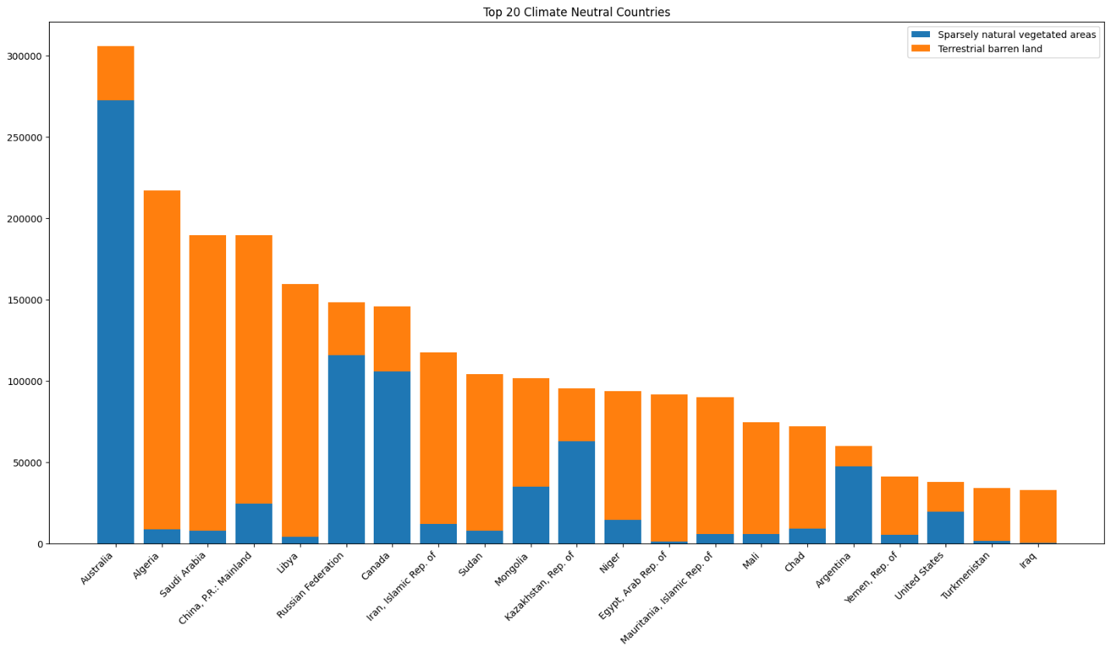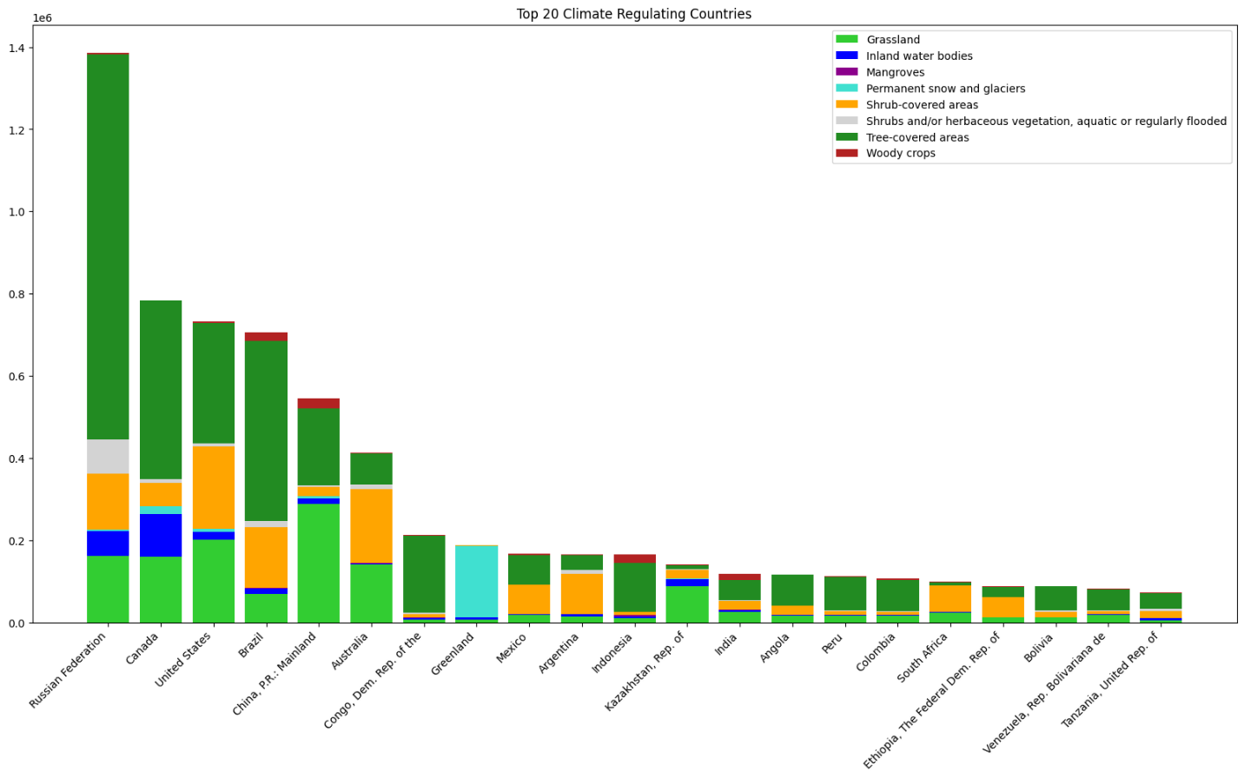

* + 1. **Disasters frequency**
* The types of natural disasters recorded include drought, flood, storm, wildfire, extreme temperature, and landslide. The countries most frequently affected by natural disasters are the United States, China, India, the Philippines, Indonesia, Vietnam, Bangladesh, and Japan, with storms and floods being the most common. These two types of disasters are primarily influenced by geographic location, situated between seas and oceans and within tropical climate zones.
* Wildfires occur frequently in countries such as the United States, Canada, Australia, and Russia, where natural areas cover a significant portion compared to the population. Vietnam, similar to other Southeast Asian countries, experiences very high frequencies of storms and floods.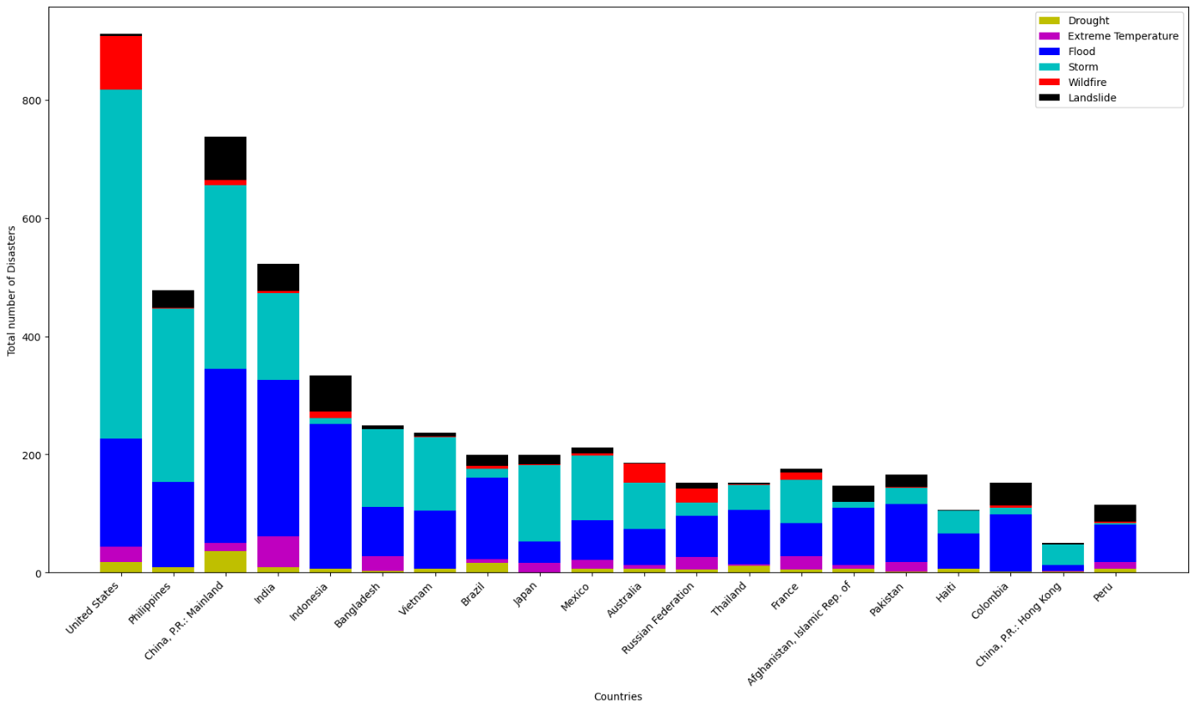

3.1.3. Mean Sea Levels Change

3.1.4 CO2 Concentrations

**3.2. Mining correlated features**

- The objective is to determine the relationships between factors affecting the climate, such as greenhouse gas emissions, atmospheric CO2 concentrations, renewable energy, land cover area, and their impact on temperature, sea level, and the frequency of natural disasters.

- To evaluate the correlation between these features, various correlation measures will be used, including Pearson correlation, Kendall rank correlation, and Spearman’s rank correlation. Additionally, since the data is in time series format, techniques for calculating correlation with different lags will be applied to examine the causal relationships between these factors.

r =

***Pearson correlation***

r =

***Kendall rank correlation***

r =

***Spearman’s rank correlation***

* Overall, the correlation measures yielded similar results, leading to the following general conclusions:
  + Natural disasters such as storms, floods, and droughts,.. along with sea level, show the highest correlation with temperature and greenhouse gas emissions, particularly CO2. This is followed by the correlation with land cover changes, especially artificial surfaces.
  + The production of renewable energy influences the increase in artificial surfaces, indirectly affecting the frequency of natural disasters, particularly storms, floods, and extreme temperature.
  + The extent of artificial surfaces is also a significant contributor to the increase in greenhouse gas emissions.
  + Sea levels are highly susceptible to most of these factors, especially emissions.
  + Some natural disasters, such as storms, floods, and extreme temperature, also influence each other.

3.3. Predictive models

Task 2 - related

4. Result analysis

4.1. Interpretation

Providing some comments about the results.

4.2. Possible mitigations

Proposing some mitigation measures derived from the results.

5. Conclusion